Azamat Salamatov

Doctor Tai Cleveland

COMP 3324

Installing Linux

3/21/2023

Installing Linux

# I installed Ubuntu and formatted all other files on my laptop,

# Initially, I downloaded VMWare, then I did not work. When I changed some settings from BIOS, I began to work.

# But then I decided to delete Windows and Download Linux.

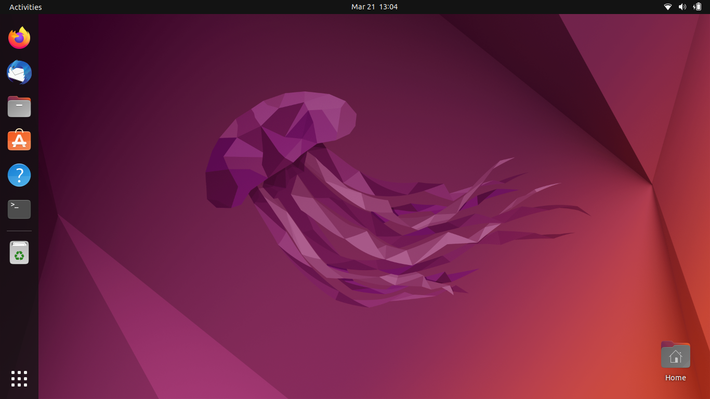

Here it is